Assignment – 07
- Write an Assembly program to find the largest number from the two elements.
Code:
MVI A,25H;
MVI B,20H;
CMP B;
JC STORE;
STORE: STA 2020H;
HLT;
Listing:
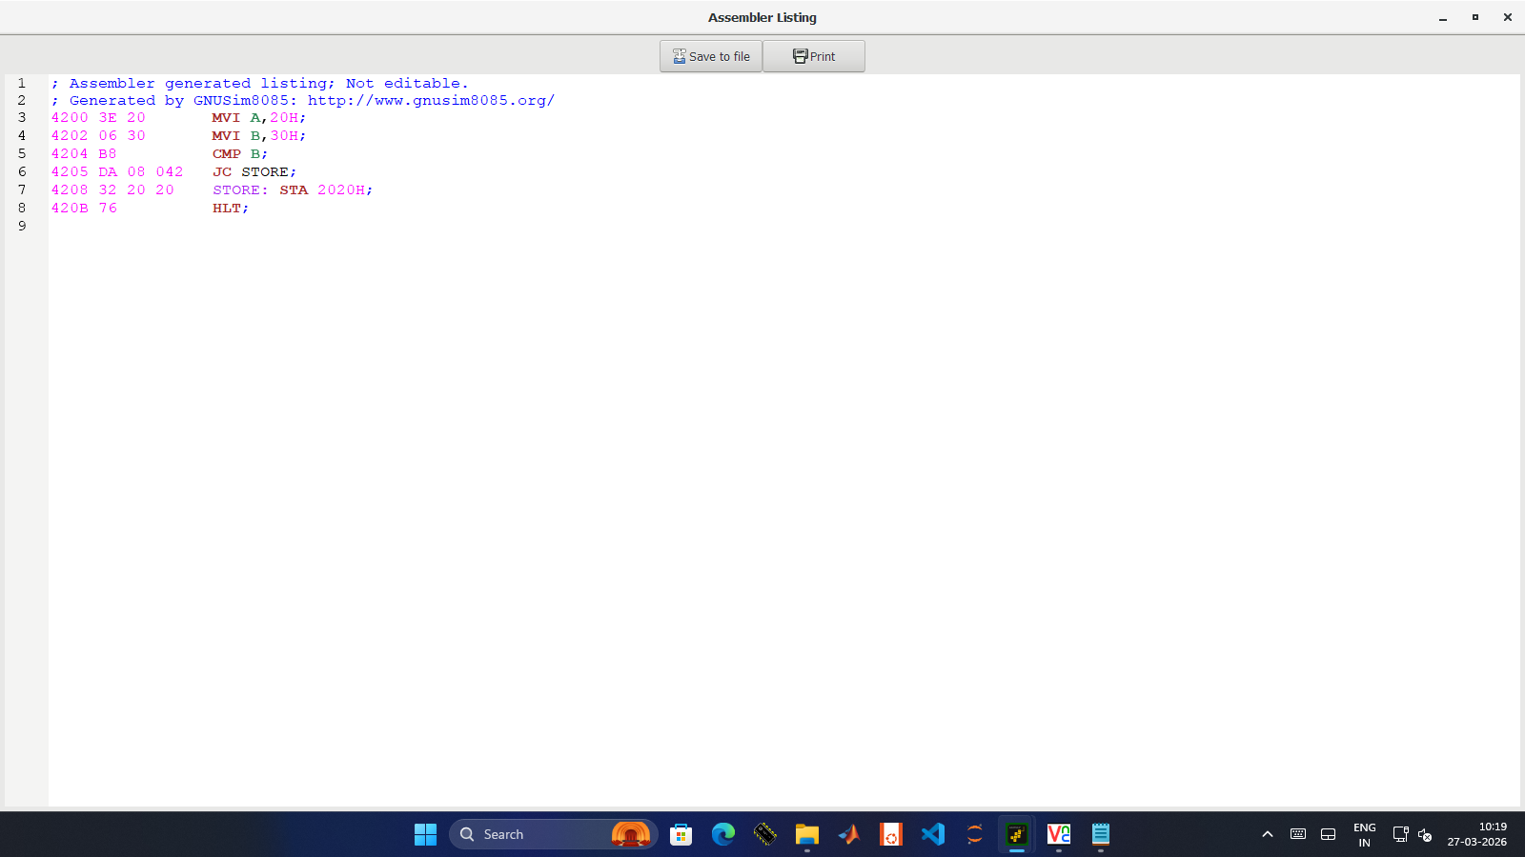

- Write a program to find the smallest of two 8bit numbers.
Code:
LDA 2020
MOV B,A
LDA 2021
CMP B
JNC L
MOV A,B
L: STA 2052
HLT
Listing:
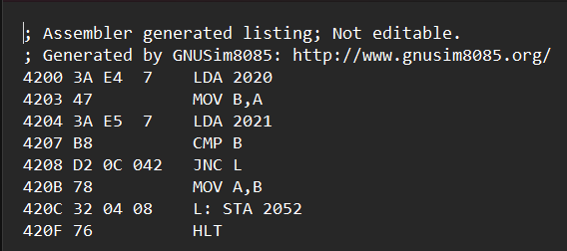

- Write a program to find the largest element from the given array.
Code:
LXI H, 2100
MOV B, M
INX H
MOV A, M
DCR B
L1: INX H
CMP M
JNC L2
MOV A,M
L2: DCR B
JNZ L1
STA 2106
HLT
Listing:
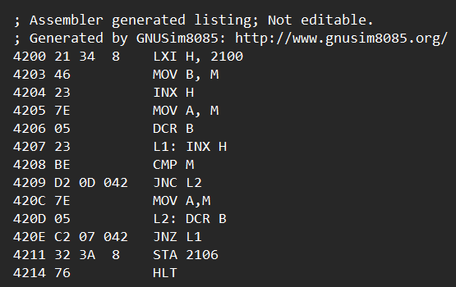
- Write a program to find the smallest element from the array of elements.
Code:
LXI H, 2100
MOV B, M
INX H
MOV A, M
DCR B
L1: INX H
CMP M
JC L2
MOV A,M
L2: DCR B
JNZ L1
STA 2106
HLT
Listing:
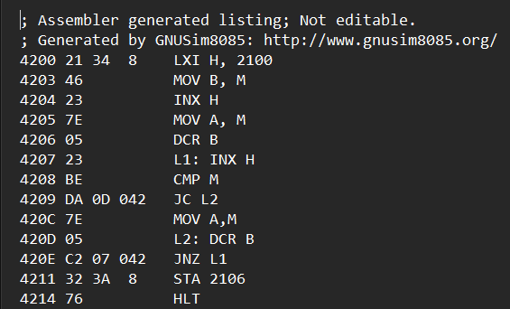
- Write a program to sort the elements in an array.
Code:
MVI B, 05H
START: LXI H, 2100
MVI C, 05H
BACK: MOV A, M
INX H
CMP M
JC SKIP
JZ SKIP
MOV D, M
MOV M, A
DCX H
MOV M,D
INX H
SKIP: DCR C
JNZ BACK
DCR B
JNZ START
HLT
Listing:
